Java Collections Framework: Interfaces (Collection, List, Set, Queue, Map, Deque) and implementations (ArrayList, LinkedList, Vector, HashSet, TreeSet, HashMap, TreeMap, PriorityQueue)

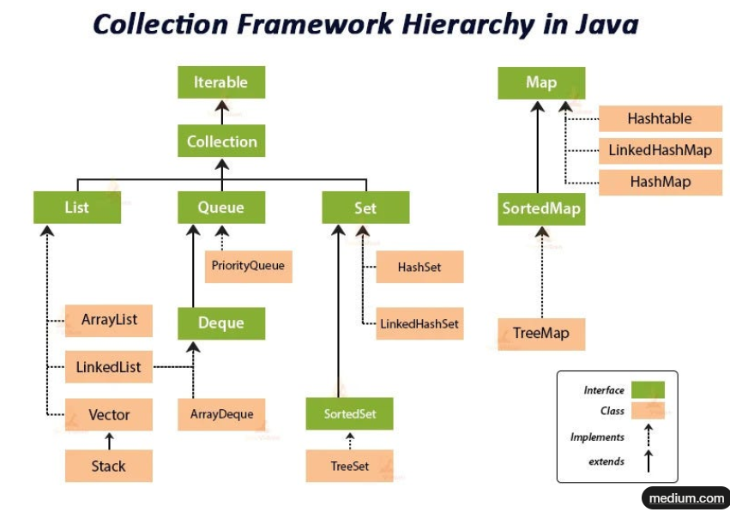

The JCF is a set of classes and interfaces in Java (under java.util package) for storing and manipulating groups of objects dynamically. It provides ready-made data structures like lists, sets, maps, and queues, making code efficient and reusable. Key benefits: resizable, type-safe (via generics like List<String>), and iterable.
JCF has two main roots:
- Collection (for single elements): Parent of List, Set, Queue.
- Map (for key-value pairs): Separate hierarchy.
All are generic, e.g., List<Integer>. Use import java.util.*; for simplicity.
Now, let's break down interfaces and implementations. I'll explain each with purpose, key methods, when to use, and a simple example.

Interfaces
Collection
- What it is: Root interface for most collections (except Map). Represents a group of objects.
- Key features: Allows adding/removing elements, checking size/emptiness, iteration (via iterator()).
- Key methods: add(E e), remove(Object o), size(), isEmpty(), contains(Object o).
- When to use: Base for List/Set/Queue; rarely used directly.
- Example:
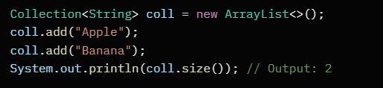

List
- What it is: Ordered collection (insertion order preserved), allows duplicates and nulls.
- Key features: Indexed access (like arrays), dynamic resizing.
- Key methods: get(int index), set(int index, E e), add(int index, E e), remove(int index).
- When to use: When order matters and you need random access (e.g., shopping cart).
- Example:
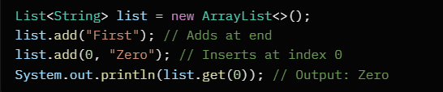

Set
- What it is: Collection with no duplicates (uses equals() for uniqueness).
- Key features: Unordered (except sorted impls), allows null (in some).
- Key methods: add(E e) (ignores duplicates), contains(Object o).
- When to use: For unique items (e.g., user IDs).
- Example:
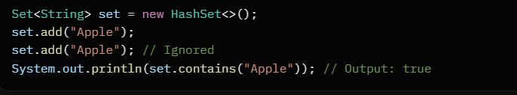

Queue
- What it is: FIFO (First-In-First-Out) structure for holding elements before processing.
- Key features: Supports offer/poll for non-blocking ops.
- Key methods: offer(E e) (add to tail), poll() (remove head), peek() (view head).
- When to use: Task scheduling (e.g., print jobs).
- Example:
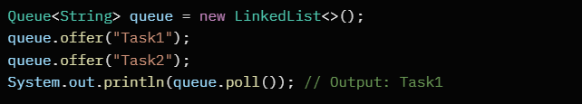

Deque (Double-Ended Queue)
- What it is: Extends Queue; allows adding/removing from both ends.
- Key features: Can act as stack (LIFO) or queue (FIFO).
- Key methods: addFirst(E e), addLast(E e), removeFirst(), removeLast().
- When to use: Undo/redo operations or sliding windows.
- Example:
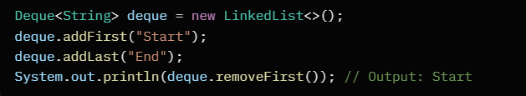

Map
- What it is: Key-value store (keys unique, values can duplicate).
- Key features: No order (except sorted impls), keys can't be null (in some).
- Key methods: put(K key, V value), get(Object key), remove(Object key), keySet(), values().
- When to use: Lookups by key (e.g., phone book).
- Example:
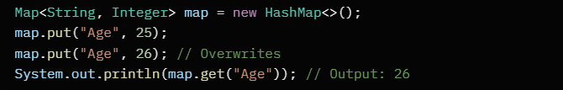
Implementations
These are concrete classes implementing the interfaces. Choose based on needs like speed, order, or thread-safety.

ArrayList (implements List)
- What it is: Resizable array; fast random access.
- Key features: Not synchronized, initial capacity 10 (grows by 50%).
- When to use: Frequent reads by index; avoid if frequent inserts/deletes in middle.
- Example:
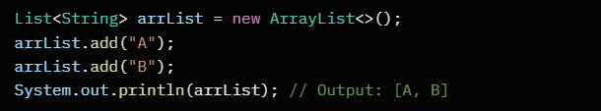

LinkedList (implements List and Deque)
- What it is: Doubly-linked list; fast inserts/deletes anywhere.
- Key features: Not synchronized, slower random access (O(n) time).
- When to use: Frequent modifications; as queue/stack.
- Example:
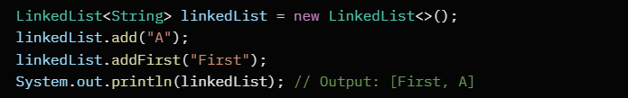

Vector (implements List)
- What it is: Like ArrayList but synchronized (thread-safe).
- Key features: Grows by 100% (doubles size), outdated for most uses (use Collections.synchronizedList() instead).
- When to use: Legacy code needing thread-safety without external sync.
- Example:
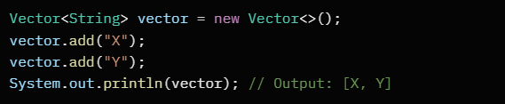

HashSet (implements Set)
- What it is: Hash table-based; no order, fast ops (O(1) average).
- Key features: Allows one null, uses hashCode/equals.
- When to use: Quick uniqueness checks.
- Example:
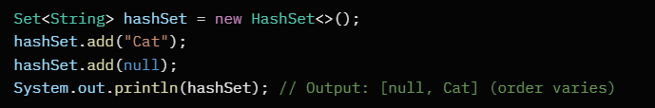

TreeSet (implements Set)
- What it is: Red-black tree-based; sorted (natural or custom order).
- Key features: No nulls, O(log n) ops, iterable in order.
- When to use: Need sorted unique elements (e.g., dictionary).
- Example:
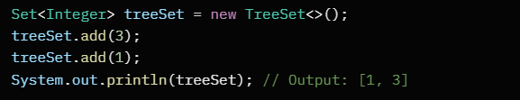

HashMap (implements Map)
- What it is: Hash table-based; no order, fast lookups.
- Key features: Allows null key/value, load factor 0.75 (resizes at 75% full).
- When to use: Unordered key-value storage.
- Example:
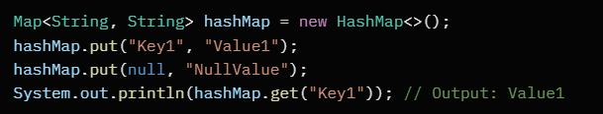

TreeMap (implements Map)
- What it is: Red-black tree-based; sorted by keys.
- Key features: No null keys, O(log n) ops, navigable (first/last keys).
- When to use: Sorted key-value (e.g., leaderboard).
- Example:
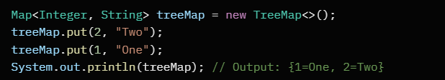

PriorityQueue (implements Queue)
- What it is: Heap-based; elements ordered by priority (min-heap default).
- Key features: Not stable (equal elements may swap), no nulls.
- When to use: Dijkstra's algorithm or task prioritization.
- Example:
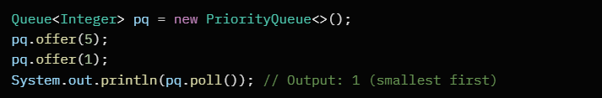

Quick Comparison Table
Aspect | List (ArrayList/LinkedList) | Set (HashSet/TreeSet) | Queue/Deque (PriorityQueue/LinkedList) | Map (HashMap/TreeMap)
Duplicates | Yes | No | Depends (Queue yes) | Keys no, values yes
Order | Insertion (ArrayList fast access) | None/Sorted | FIFO/Priority/Both ends | None/Sorted keys
Access Time | O(1) index (ArrayList) | O(1)/O(log n) | O(1) ends | O(1)/O(log n) get
Use Case | Sequences | Unique items | Processing lines | Key lookups
Thread-Safe | No (Vector yes) | No | No | No

Differences: Array vs. ArrayList, List vs. Set, HashMap vs. Hashtable, Iterator vs. ListIterator vs. Enumeration

Array vs. ArrayList
Arrays and ArrayLists are both used to store collections of data, but they differ in flexibility and performance. Think of an Array as a fixed-size box—you decide the size upfront and can't easily change it. ArrayList is like a stretchy bag that grows or shrinks as needed.
Aspect | Array | ArrayList
Size | Fixed length (must specify size at creation, e.g., int[] arr = new int[5];). Can't resize without creating a new one. | Dynamic size (grows automatically, e.g., ArrayList<Integer> list = new ArrayList<>();). Use add() to append, remove() to shrink.
Type | Can hold primitives (e.g., int[]) or objects. | Only objects (use wrappers for primitives, e.g., Integer).
Performance | Faster access (arr[0]) since it's contiguous memory. | Slightly slower access (list.get(0)) due to overhead, but negligible for most uses.
Methods | Basic indexing only; no built-in methods like sort or search. | Rich methods: size(), contains(), addAll(), removeIf().
Generics | No generics support. | Supports generics for type safety (e.g., ArrayList<String>).
Use Case | When size is known and fixed, like coordinates in a game. | When size varies, like a shopping cart list.

Example Code:
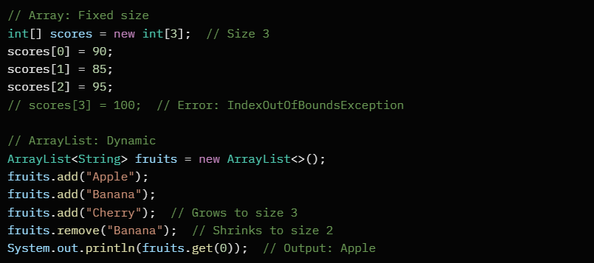

List vs. Set
List and Set are both interfaces in Java's Collections Framework for storing multiple items, but List allows duplicates and order, while Set prevents duplicates and doesn't guarantee order (except SortedSet variants).
Aspect | List (e.g., ArrayList, LinkedList) | Set (e.g., HashSet, TreeSet)
Duplicates | Allows duplicates (e.g., [1, 1, 2]). | No duplicates (adds only unique, e.g., {1, 2}).
Order | Maintains insertion order. | No guaranteed order (HashSet random; TreeSet sorted).
Access | Indexed access (get(0)), supports positional ops. | No indexing; must iterate or use contains().
Performance | O(1) for add/get in ArrayList; O(n) for LinkedList inserts. | O(1) average for add/contains in HashSet; O(log n) in TreeSet.
Size | Can be empty or grow. | Same, but uniqueness limits growth.
Use Case | Ordered lists like to-do tasks. | Unique collections like email addresses.

Example Code:
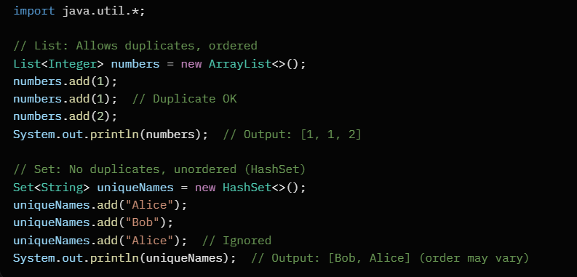

HashMap vs. Hashtable
Both are key-value stores (like dictionaries), but HashMap is newer, faster for single-threaded use, and allows nulls, while Hashtable is legacy, thread-safe, and doesn't allow nulls.
Aspect | HashMap | Hashtable
Nulls | Allows one null key, many null values. | No null keys or values.
Thread-Safe | Not synchronized (use Collections.synchronizedMap() for multi-thread). | Synchronized (thread-safe but slower).
Performance | Faster (no locking overhead). | Slower due to synchronization on every method.
Inheritance | Implements Map; added in JDK 1.2. | Implements Map and is a Vector subclass; legacy from JDK 1.0.
Iteration | Fail-fast iterators (throw ConcurrentModificationException if modified during iteration). | Fail-safe (allows modification during iteration).
Use Case | General-purpose, like caching user sessions. | Multi-threaded legacy code, like old servers.

Example Code:
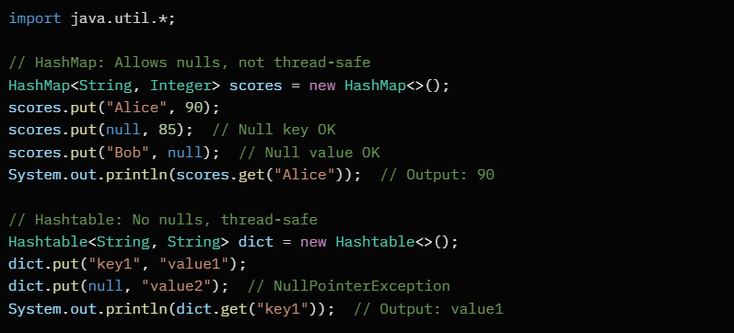

Iterator vs. ListIterator vs. Enumeration
These are ways to traverse collections, but Iterator is basic for forward traversal, ListIterator adds backward and modification, and Enumeration is old-school for legacy classes like Hashtable.
Aspect | Iterator (for List/Set/Map views) | ListIterator (only for List) | Enumeration (for legacy like Vector/Hashtable)
Direction | Forward only (hasNext(), next()). | Bidirectional (hasNext()/next(), hasPrevious()/previous()). | Forward only (hasMoreElements(), nextElement()).
Modification | Can remove() during iteration. | Can add(), remove(), set() during iteration. | No modification; read-only.
Supported On | Any Collection (e.g., List, Set). | Only List implementations. | Legacy: Vector, Stack, Hashtable.
Fail Behavior | Fail-fast (throws if concurrent change). | Fail-fast. | Fail-safe (no exception on changes).
Performance | Efficient for traversal. | Slightly more overhead for extras. | Similar to Iterator but outdated.
Use Case | Simple loop over any collection. | Need to edit or reverse in lists. | Migrating old code.
Example Code:
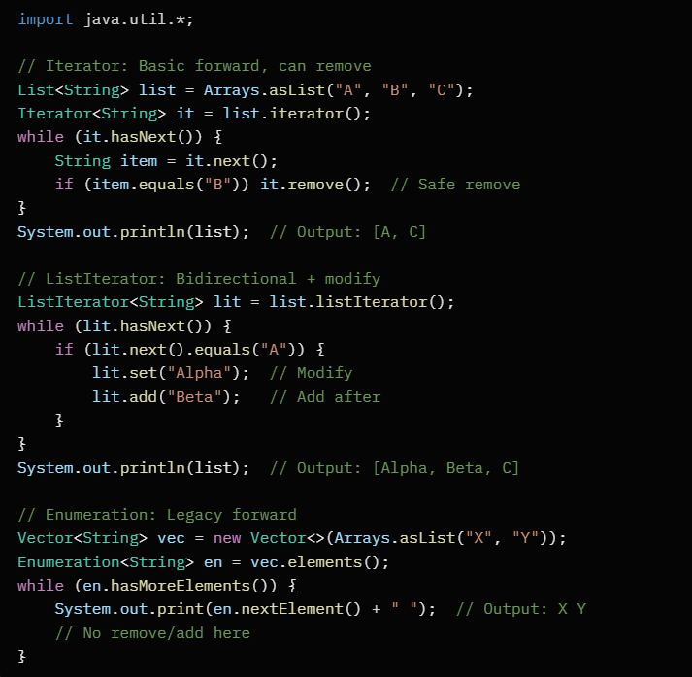

Generics: Type safety, bounded types, and wildcards

What Are Java Generics?
Generics let you write classes, interfaces, and methods that work with any type while keeping it flexible and safe. Introduced in Java 5, they use angle brackets <T> (where T is a placeholder for any type) to parameterize code. Think of it like a blueprint: you define a structure once, but plug in different types (like String or Integer) at use time.
Why use them? Without generics, you'd cast types manually (risky and error-prone). With generics, the compiler catches mistakes early.
Type Safety: The Core Benefit
Type safety means the compiler enforces rules so you can't mix incompatible types at runtime—errors happen at compile time instead. This prevents ClassCastException surprises.

Example: Without Generics (Unsafe)
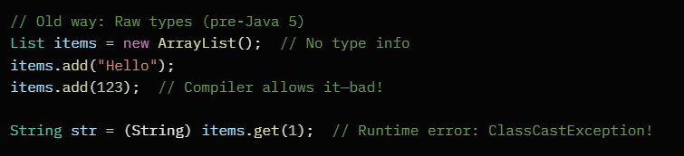

Example: With Generics (Safe)
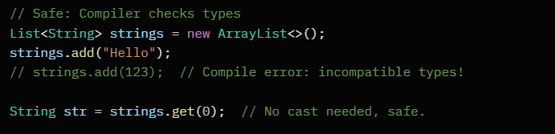

Here, <String> tells the compiler: "Only strings allowed." If you try adding an Integer, it fails at compile time. Generics erase to Object at runtime (type erasure), but compile-time checks save you.
Interview Tip: Mention PECS (Producer Extends Consumer Super) later—it's wildcard-related, but ties back to safety.

Bounded Types: Restricting What T Can Be
Sometimes you don't want any type—you need limits. Bounded types add constraints using extends (for upper bounds) or super (for lower bounds).
Upper Bounded Types (<T extends SuperType>)
Limits T to a specific class/interface or its subtypes. Useful when you need methods from the bound type.

Example: Stack for Numbers Only
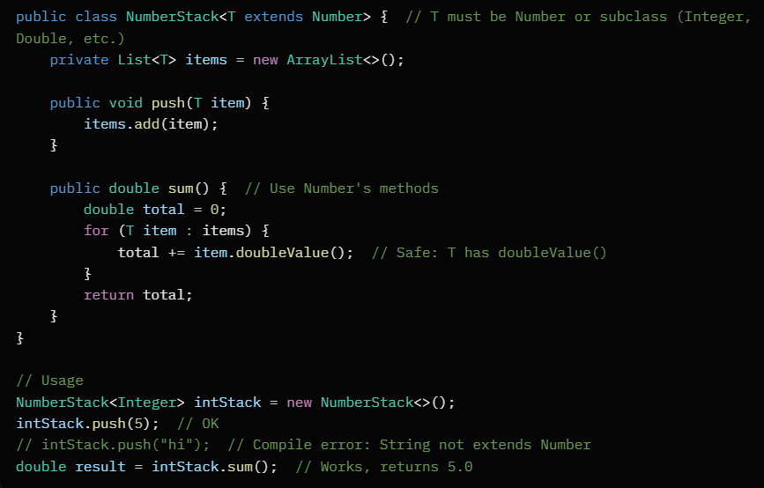
Why? Ensures T has Number methods like doubleValue(). Multiple bounds? Use &: <T extends Number & Comparable<T>>.

Lower Bounded Types (<T super SubType>)
Less common in class definitions, but powerful in wildcards (see below). It means T is the subtype or a supertype—good for "writing" to collections.
Interview Tip: Upper bounds are for reading (consuming) data; lower for writing (producing). But we'll see this in wildcards.

Wildcards: Flexible Matching with ?
Wildcards (?) make generics more reusable when exact types don't matter, but you still want safety. They're like "any type" with optional bounds.
Unbounded Wildcard (<?>)
Matches any type—use when you don't care about the exact type, just need to read (but not add arbitrary items).

Example: Print Any List
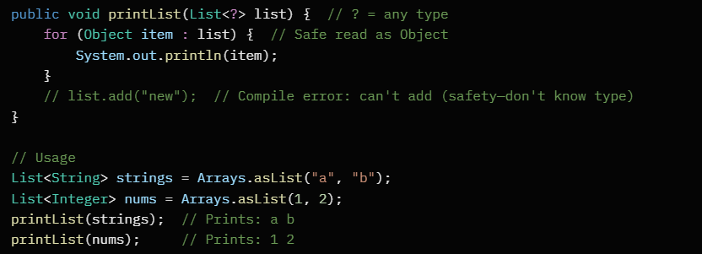
Why? Allows one method for all lists without raw types. But no writes—prevents errors.

Upper Bounded Wildcard (<? extends SuperType>)
Matches the supertype or subtypes—great for reading (producing) data. You can get items but not add (except null).
Example: Box Sum (from earlier NumberStack idea)
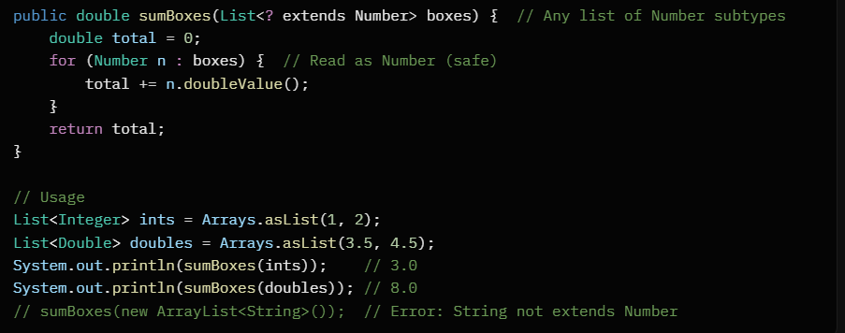
This is "covariant"—subtypes flow up. Remember PECS: Use extends when the list "produces" (you read from it).

Lower Bounded Wildcard (<? super SubType>)
Matches the subtype or supertypes—ideal for writing (consuming) data. You can add subtypes but read only as Object.

Example: Add Dogs to Animal Lists
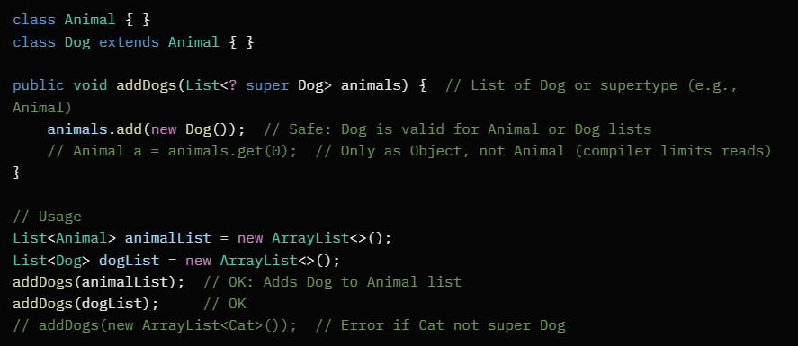
This is "contravariant"—supertypes flow down. PECS: Use super when the list "consumes" (you add to it).
Interview Tip: Explain PECS fully: Producer (read) use **E**xtends, Consumer (write) use **S**uper. Unbounded ? for neutral cases.

Quick Comparison Table
Feature | Use Case | Read Safe? | Write Safe? | Example Bound
<T> | Exact type | Yes | Yes | <String>
<?> | Any type, read-only | Yes (as Object) | No | N/A
<? extends T> | Read from subtypes | Yes (as T) | No | <? extends Number>
<? super T> | Write to supertypes | No (as Object) | Yes (T or subtypes) | <? super Dog>

Difference between T and ? in Java Generics:
Feature | T (Type Parameter) | ? (Wildcard)
Definition | Declares a generic type (used when defining a class, method, or interface). | Represents an unknown type (used when consuming an already generic type).
Used In | Class or method declaration | Method parameters or variable types
Can you set/add elements? | ✅ Yes — you know the type (T) | ⚠️ Usually No — type is unknown
Can you get/read elements? | ✅ Yes — returns type T | ✅ Yes — returns Object or bounded type
Example (Declaration) | class Box<T> { void add(T item) {} } | void print(Box<?> box)
Purpose | Define a new generic structure | Work flexibly with any generic type

Comparable vs. Comparator for sorting

Why Use Comparable and Comparator?
In Java, sorting collections (like Lists or Arrays) of objects requires defining how to compare them. Comparable and Comparator are interfaces that help do this. Collections.sort() or Arrays.sort() use them to order elements. Think of Comparable as "built-in" sorting for your class, and Comparator as a "plug-in" for flexible sorting.

Comparable: Natural Ordering Inside the Class
- What it is: Your class implements Comparable<T> (where T is your class type). It adds a compareTo(T other) method to define the "natural" order (e.g., alphabetical by name).
- How it works: Return negative if this < other, zero if equal, positive if this > other.
- Pros: Simple for one default sort; works directly with sorted collections like TreeSet.
- Cons: Pollutes your class with sorting logic; hard to change order later.
- When to use: For classes with a clear single sort order, like String or Integer.
Example: Sort Student objects by name.
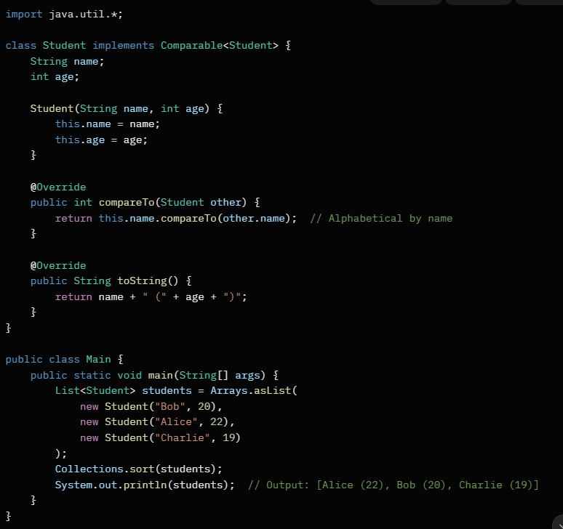
Comparator: Custom Ordering Outside the Class
- What it is: A separate class implements Comparator<T>. It has compare(T o1, T o2) method for specific sorting rules.
- How it works: Same return values as compareTo: negative if o1 < o2, zero if equal, positive if o1 > o2.
- Pros: Keeps class clean; easy to create multiple comparators (e.g., sort by age, then by name); works with anonymous classes or lambdas.
- Cons: Extra class needed; slightly more code for simple cases.
- When to use: When you need different sorts, or can't modify the original class (e.g., sorting third-party objects).
Example: Sort same Student class (now without Comparable) by age, using a lambda for brevity.
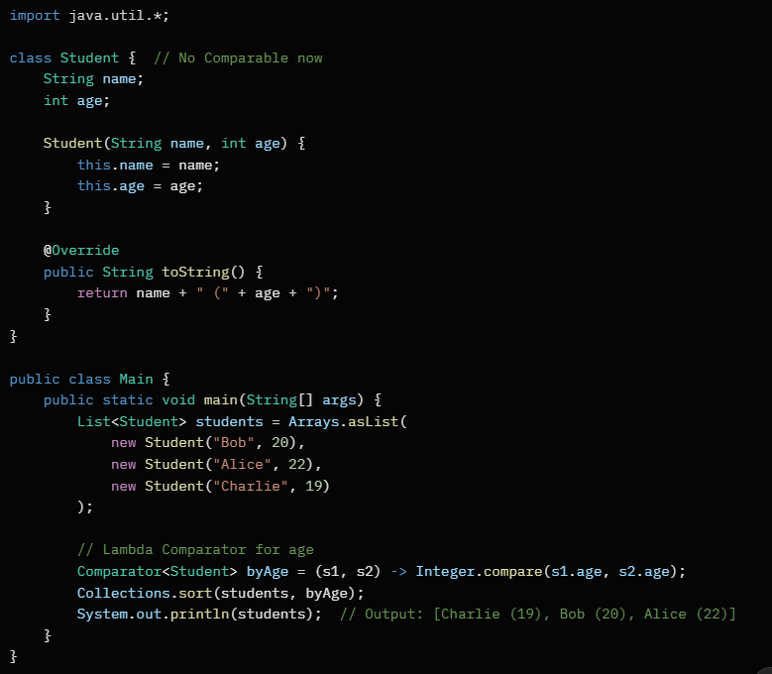

Key Differences
Aspect | Comparable | Comparator
Interface | compareTo(T other) in the class | compare(T o1, T o2) in separate class
Location | Inside the sortable class | Outside (e.g., anonymous/lambda)
Flexibility | One fixed order per class | Multiple orders possible
Usage | Collections.sort(list) | Collections.sort(list, comparator)
Null Safety | Throws NPE if null; handle manually | Can return specific value for nulls

Interview Tips
- Common Q: "Can Comparator sort in reverse?" Yes, use Collections.reverseOrder() or multiply return value by -1.
- Edge Cases: Handle equals (return 0 to avoid duplicates in TreeSet); nulls (e.g., return -1 if o1 null).
- Modern Java: Prefer lambdas/method references for Comparator (e.g., Comparator.comparing(Student::getAge)).
- Performance: Both O(n log n) with sort; Comparator adds minor overhead but negligible.

Internal workings: How ArrayList resizes, HashMap hashing and collision resolution

ArrayList Resizing
Imagine ArrayList as a stretchy backpack that starts small but grows as you stuff more items in. Under the hood, it's backed by a fixed-size array, but when it runs out of space, it creates a bigger array and moves everything over. This keeps adds efficient (amortized O(1) time).
Key Mechanics:
- Initial Setup: Default capacity is 10 elements. If you specify one (e.g., new ArrayList<>(20)), it starts that big. It tracks current size (elements added) vs. capacity (array slots).
- When It Triggers: Resize happens automatically on add() when size == capacity. It doesn't shrink automatically—only grows.
- How It Grows: New capacity = old capacity * 1.5 (growth factor). This is a sweet spot: too slow (like doubling) wastes memory; too fast (like 1.1x) causes frequent copies.
  - Math: For old capacity n, new = n + (n >> 1) (bit shift for /2, so +50%).
- Copy Process: Creates new array, uses System.arraycopy() to copy all elements (O(n) time, but rare enough to average out).
- Edge Cases: If initial capacity is 0 or unspecified, first add sets it to 10. Trim excess space manually with trimToSize().
Simple Example:
Start with empty ArrayList (capacity 10). Add 11 strings:
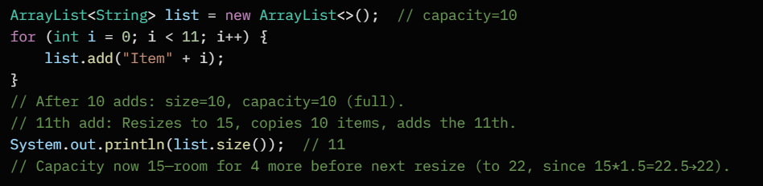
Analogy: Like adding passengers to a bus. At 10 seats, it swaps to a 15-seater van and reloads everyone.
Interview tip: Mention why 1.5x? It minimizes copy operations over time (proven by amortized analysis).

HashMap: Hashing and Collision Resolution
Think of HashMap as a filing cabinet with numbered drawers (buckets). Keys go into drawers based on a "hash code" (like a magic number from the key). If two keys want the same drawer (collision), they share it via a chain or tree—keeping lookups fast (average O(1)).
Hashing Basics:
- Hash Function: Calls key.hashCode() (int value, e.g., "apple".hashCode() = -2088296744). Then modulates to bucket index: index = (hash ^ (hash >>> 16)) & (capacity - 1). (XOR and shift for better spread; & with capacity-1 since capacity is power of 2, like 16→15.)
  - Why power of 2? Fast bit ops, uniform distribution.
- Capacity & Load Factor: Starts at 16 buckets. Default load factor 0.75—resizes when entries > capacity * 0.75 (e.g., 12 entries → resize to 32).
- Resize: Doubles capacity, rehashes all keys into new buckets (O(n) but infrequent).
Collision Resolution:
- Pre-Java 8: Chaining—each bucket is a linked list. Colliding keys append to the list; lookup traverses it (worst O(n) if all collide).
- Java 8+: Still chaining, but if a bucket's list hits 8+ nodes, it converts to a red-black tree (balanced BST, O(log n) worst case). Under 6 nodes, back to list. Thresholds prevent tree overhead on small chains.
- Null Handling: Null key goes to bucket 0; null values allowed anywhere.
- Equals() Role: HashCode finds bucket; equals() confirms exact match in chain/tree.
Simple Example:
Put keys that collide (e.g., "cat" and "act" both hash to same index modulo small capacity):
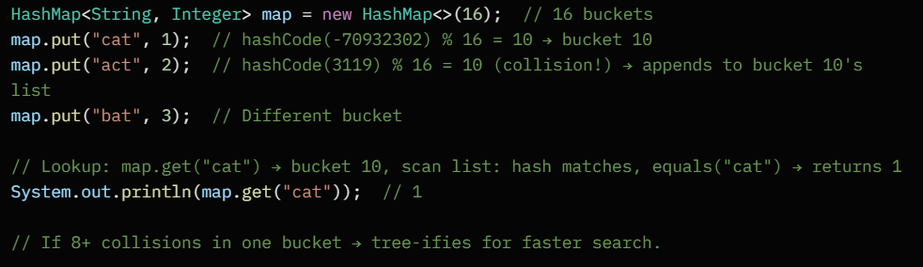
Analogy: Hashing is like assigning library books to shelves by first letter's code. Collision? Stack on the shelf (list) or organize alphabetically (tree) if too messy.
Interview tip: Stress thread-safety (HashMap isn't—use ConcurrentHashMap) and why rehash on resize (old indices invalid).

Fail-fast vs. fail-safe iterators, and synchronized collections

Iterators in Java: Basics
Iterators are like pointers that let you safely traverse collections (e.g., List, Set) one element at a time using methods like hasNext() and next(). Java's collections have two iterator behaviors: fail-fast and fail-safe, which handle changes (like adding/removing elements) during iteration differently. These tie into thread-safety.

Fail-Fast Iterators
These are the default in non-thread-safe collections (e.g., ArrayList, HashSet, HashMap). They detect structural modifications (add/remove/replace) during iteration and immediately throw ConcurrentModificationException to prevent unpredictable behavior. They use a modCount flag: if it changes mid-iteration, boom—exception.
Why? Keeps things consistent in single-threaded code; forces you to handle changes explicitly.
Example:
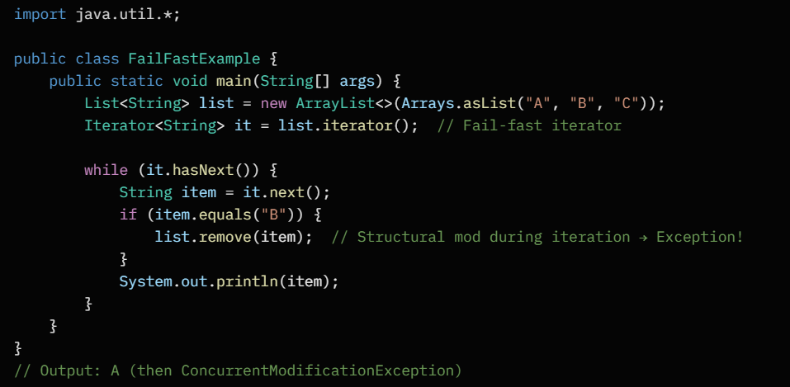
Fix: Use it.remove() instead of list.remove() to modify via the iterator.

Fail-Safe Iterators
These come from concurrent/thread-safe collections (e.g., CopyOnWriteArrayList, ConcurrentHashMap). They iterate over a snapshot/copy of the collection at iteration start, so external mods (add/remove) don't affect the loop—no exceptions. But you might see stale data.
Why? Designed for multi-threaded environments; prioritizes safety over immediate visibility.
Example:
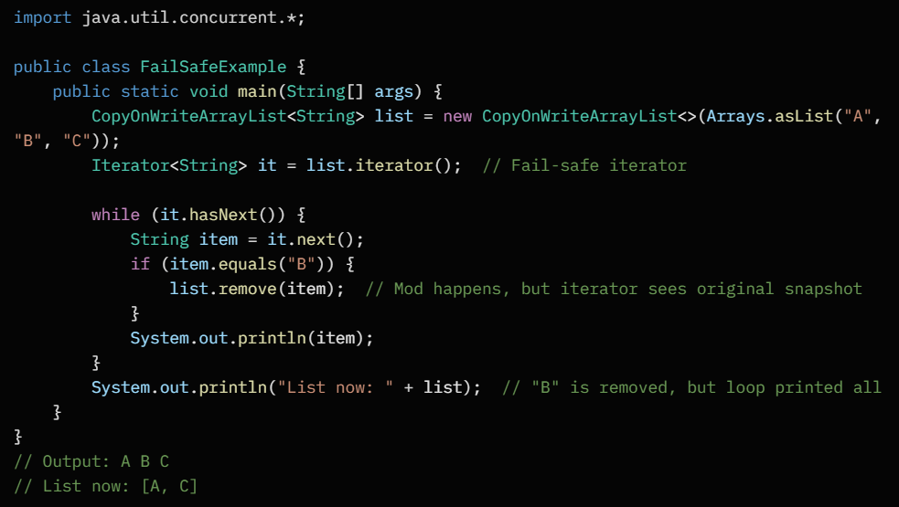
Note: CopyOnWriteArrayList creates a new copy on writes—great for read-heavy scenarios, but memory-intensive.

Synchronized Collections
These are wrapper classes from java.util.Collections.synchronizedX() (e.g., synchronizedList(), synchronizedMap()) that make non-thread-safe collections thread-safe by wrapping them with locks. All operations are atomic, but their iterators are still fail-fast (not fail-safe). Use for basic concurrency; for advanced, prefer java.util.concurrent classes.
Why? Quick way to add thread-safety without rewriting code, but iterators can still throw exceptions on concurrent mods.
Example:
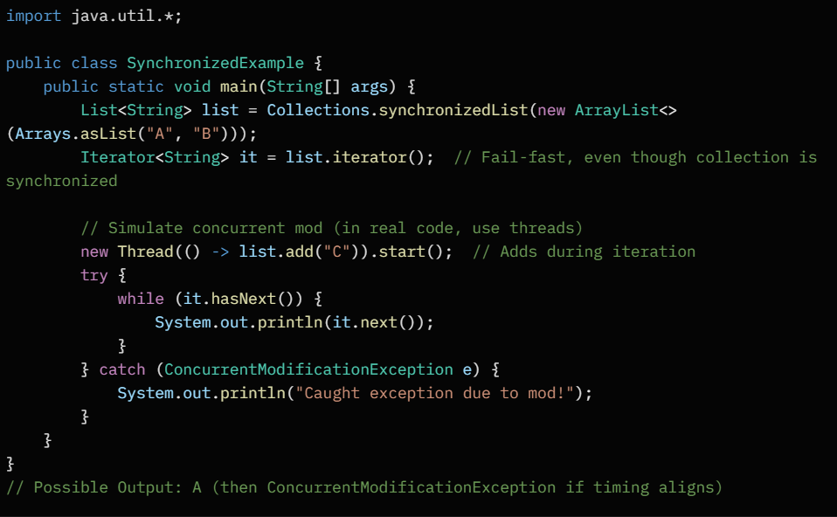
Pro tip: For full fail-safe, use ConcurrentHashMap's iterators—they're weakly consistent (see changes eventually, no exceptions).

Quick Comparison Table
Aspect | Fail-Fast Iterators | Fail-Safe Iterators | Synchronized Collections
Collections | ArrayList, HashMap (non-concurrent) | CopyOnWriteArrayList, ConcurrentHashMap | Wrappers like synchronizedList()
On Mod During Iteration | Throws ConcurrentModificationException | No exception; works on snapshot | Thread-safe ops, but fail-fast iterators
Thread-Safety | Not inherently safe | Yes, concurrent-safe | Yes (via locks), but iterators aren't fail-safe
Performance | Fast (direct access) | Slower (copy overhead) | Overhead from synchronization
Use Case | Single-threaded, strict consistency | Multi-threaded reads with writes | Simple thread-safety upgrade
In interviews, emphasize: Fail-fast catches bugs early; fail-safe avoids crashes in concurrency. Always prefer concurrent collections for threads over synchronized wrappers for better perf.

Common data structures: Stacks, queues, linked lists, trees (binary, BST), graphs, heaps

Introduction to Common Data Structures
Data structures are ways to organize and store data efficiently for operations like insertion, deletion, and searching. In Java interviews, you'll often need to explain them, implement basic operations, and compare time complexities (e.g., O(1) for constant time, O(n) for linear time). Below, I'll cover each one simply: what it is, key operations, use cases, Java implementation snippets, and examples. Focus on understanding trade-offs—no fluff.

Stacks
What it is: A LIFO (Last In, First Out) structure, like a stack of plates. You add/remove from the top only.
Key Operations:
- Push: Add to top (O(1))
- Pop: Remove from top (O(1))
- Peek: View top without removing (O(1))
- IsEmpty: Check if empty (O(1))
Use Cases: Undo/redo in editors, function call tracking (recursion), expression evaluation (e.g., parentheses matching).
Java Example: Use Stack class (extends Vector) or ArrayDeque for efficiency.
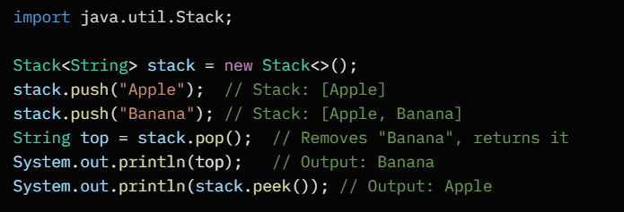
Interview Tip: Implement with array for fixed size or linked list for dynamic. Time: All O(1) average.

Queues
What it is: A FIFO (First In, First Out) structure, like a line at a checkout. Add to rear, remove from front.
Key Operations:
- Enqueue: Add to rear (O(1))
- Dequeue: Remove from front (O(1))
- Peek: View front (O(1))
- IsEmpty: Check if empty (O(1))
Use Cases: Task scheduling (e.g., print jobs), BFS in graphs, buffering in networks.
Java Example: Use LinkedList as Queue or ArrayDeque (preferred over legacy Queue).
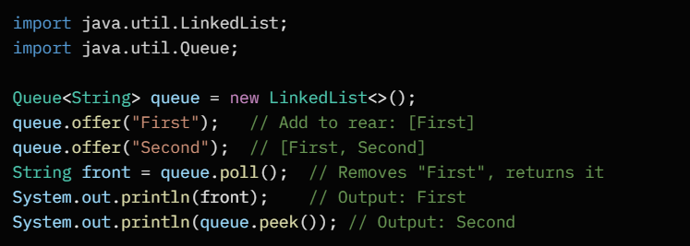
Interview Tip: Circular array for space efficiency. Deque variant allows add/remove from both ends (e.g., for sliding windows).

Linked Lists
What it is: A chain of nodes where each holds data and a pointer to the next (singly) or previous/next (doubly). Unlike arrays, no fixed size—dynamic insertion/deletion.
Key Operations (Singly Linked):
- Insert at head/tail: O(1) with tail pointer
- Delete by value: O(n) (traverse to find)
- Search: O(n)
- Traverse: O(n)
Use Cases: Implement stacks/queues, when frequent inserts/deletes (e.g., music playlist).
Java Example: No built-in, but LinkedList class implements it (doubly-linked).
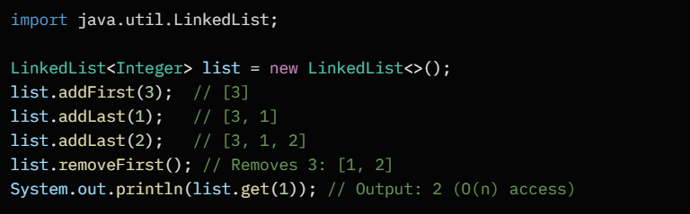
Interview Tip: Detect cycles (Floyd's tortoise-hare). Doubly-linked: O(1) delete if node known. Vs. ArrayList: Slower random access, but better for inserts.

Trees (Binary Trees)
What it is: Hierarchical structure with nodes having ≤2 children (left/right). Root at top, leaves at bottom. No cycles.
Key Operations:
- Insert: O(h) where h=height (O(log n) balanced)
- Search: O(h)
- Delete: O(h)
- Traversal: In-order (sorted), Pre-order, Post-order (all O(n))
Use Cases: File systems, decision trees, expression parsing.
Java Example: Custom Node class; no built-in binary tree, but TreeSet for ordered.
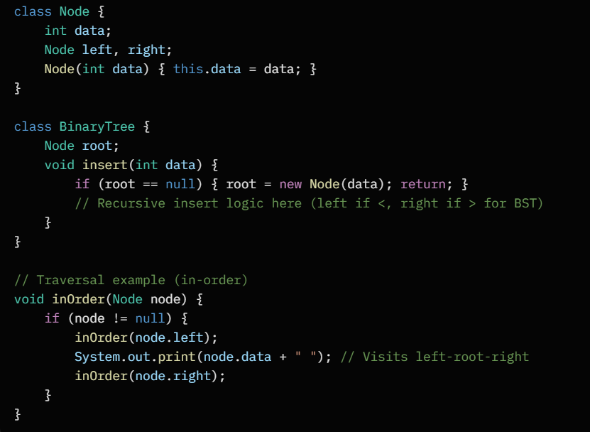
Interview Tip: Height-balanced? Skewed tree worst-case O(n). Draw: Root=5, left=3, right=7.

Binary Search Trees (BST)
What it is: A binary tree where left child < parent < right child. Enables fast lookups.
Key Operations: Same as binary tree, but O(log n) average if balanced.
- Insert/Search/Delete: Traverse based on comparison.
Use Cases: Sorted data storage, autocomplete, range queries.
Java Example: Built-in TreeSet or custom.
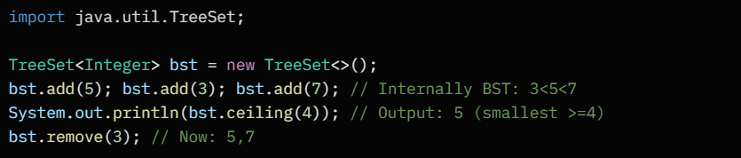

Custom Insert Snippet:
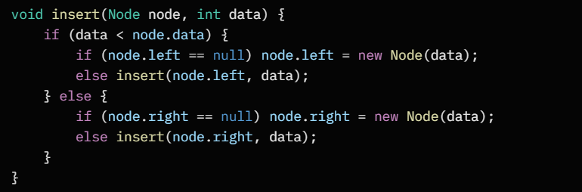
Interview Tip: Balance with AVL/Red-Black (TreeMap uses Red-Black). Duplicate handling? Usually not allowed.

Graphs
What it is: Nodes (vertices) connected by edges. Directed (one-way) or undirected (two-way). Can have cycles/weights.
Representations:
- Adjacency List: Array of lists (space-efficient, O(V+E))
- Adjacency Matrix: 2D array (fast edge check O(1), but O(V²) space)
Key Operations:
- Add edge: O(1)
- Traversal: DFS (stack/recursion, O(V+E)), BFS (queue, O(V+E))
- Shortest Path: Dijkstra (O((V+E)log V) with heap)
Use Cases: Social networks (friends), maps (routes), web crawling.
Java Example: Adjacency list with HashMap<List>.
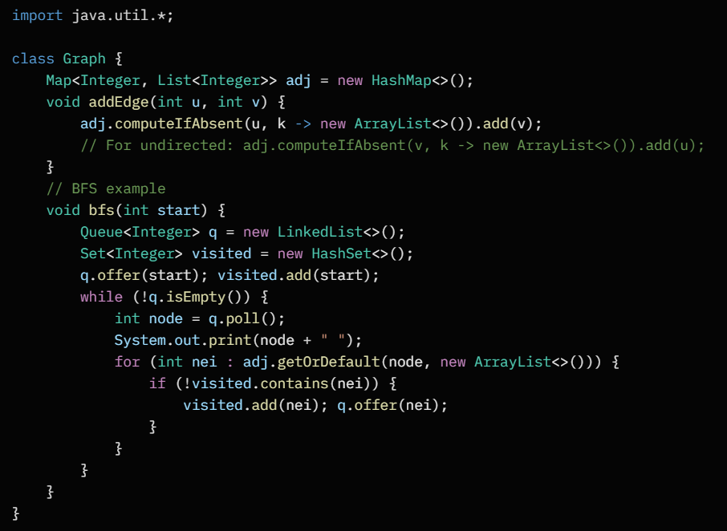
Interview Tip: Detect cycles? DFS with recursion stack. Weighted? Use PriorityQueue for Dijkstra.

Heaps
What it is: Complete binary tree satisfying heap property: Min-heap (parent ≤ children), Max-heap (parent ≥ children). Stored in array for efficiency.
Key Operations:
- Insert: O(log n) (bubble up)
- Extract Min/Max: O(log n) (bubble down)
- Peek: O(1)
- Build Heap: O(n)
Use Cases: Priority queues (task scheduling), Dijkstra, median finding.
Java Example: PriorityQueue (min-heap by default).
